Deploy web application using azure app service

Right click on Project and click on ‘Publish’

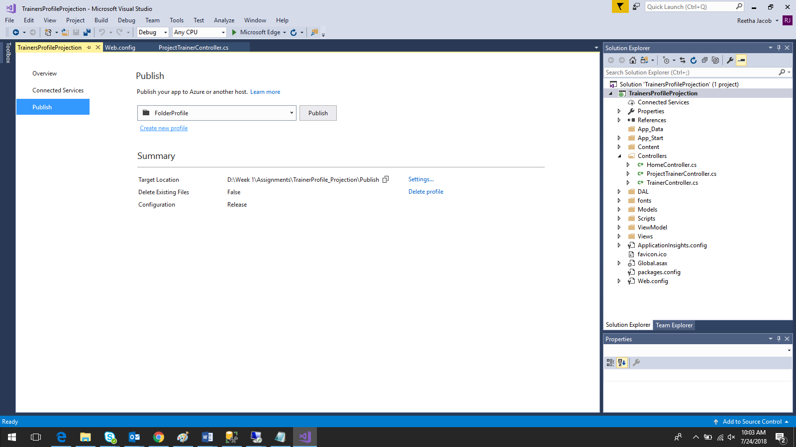

Click on new profile

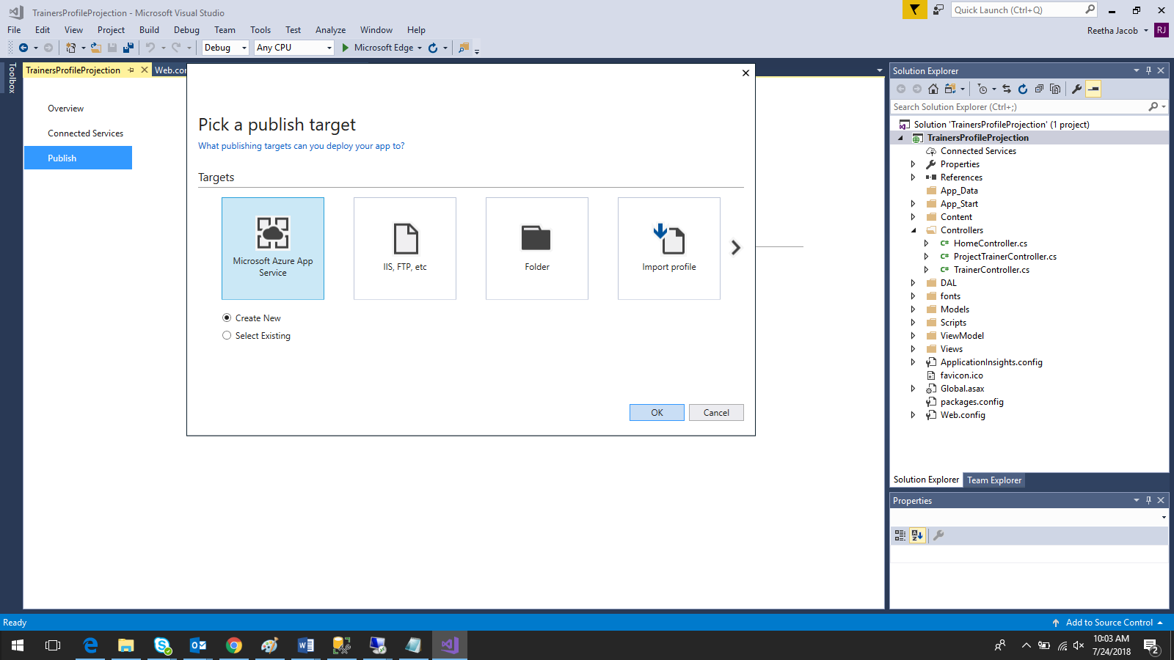

Select Microsoft Azure App Service, create new and click on OK.

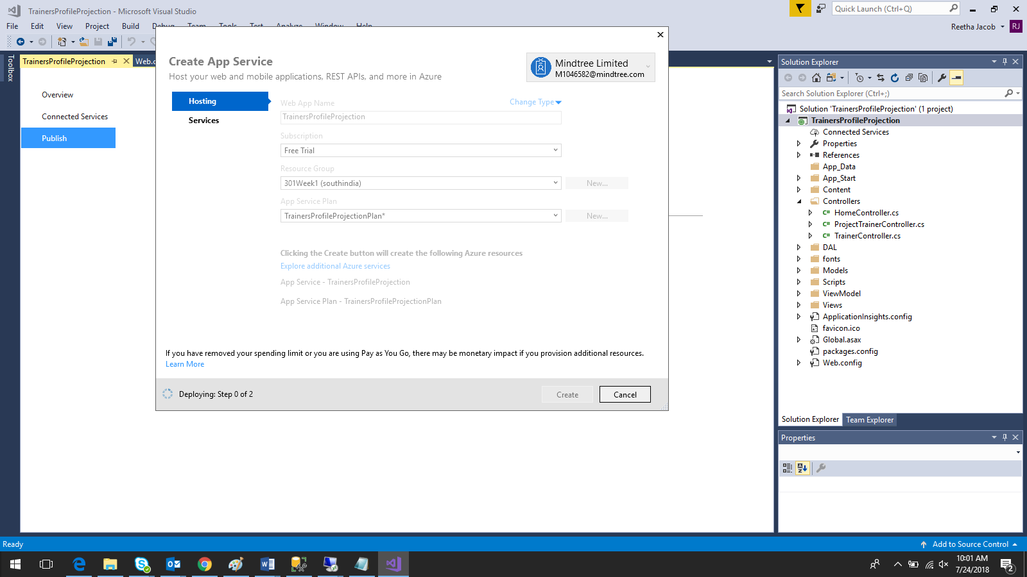

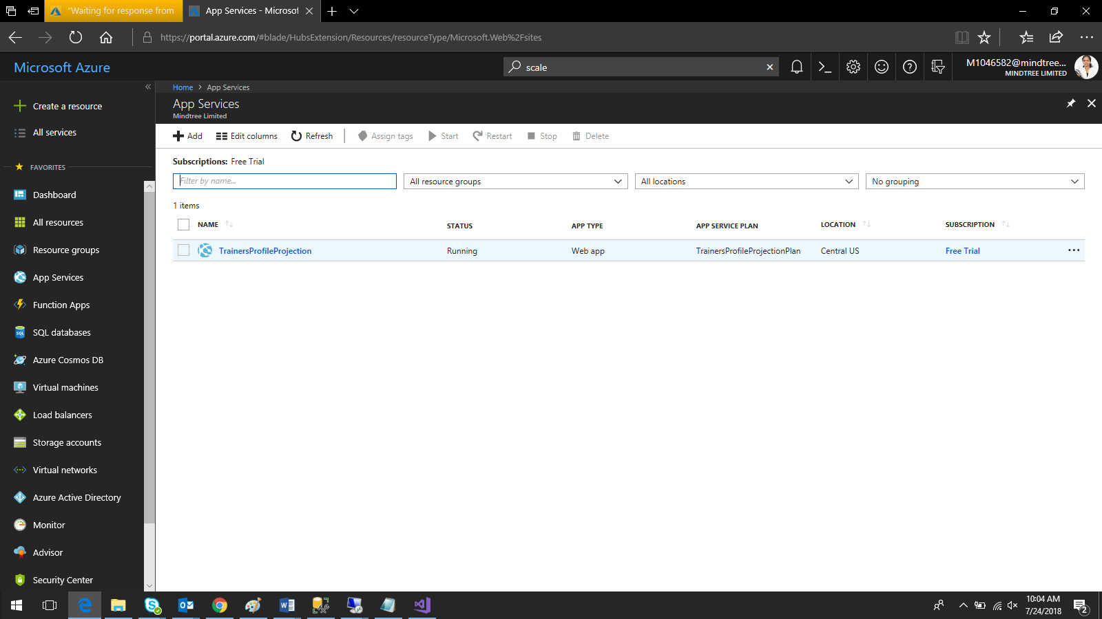

Right click on the App service name and click on browse

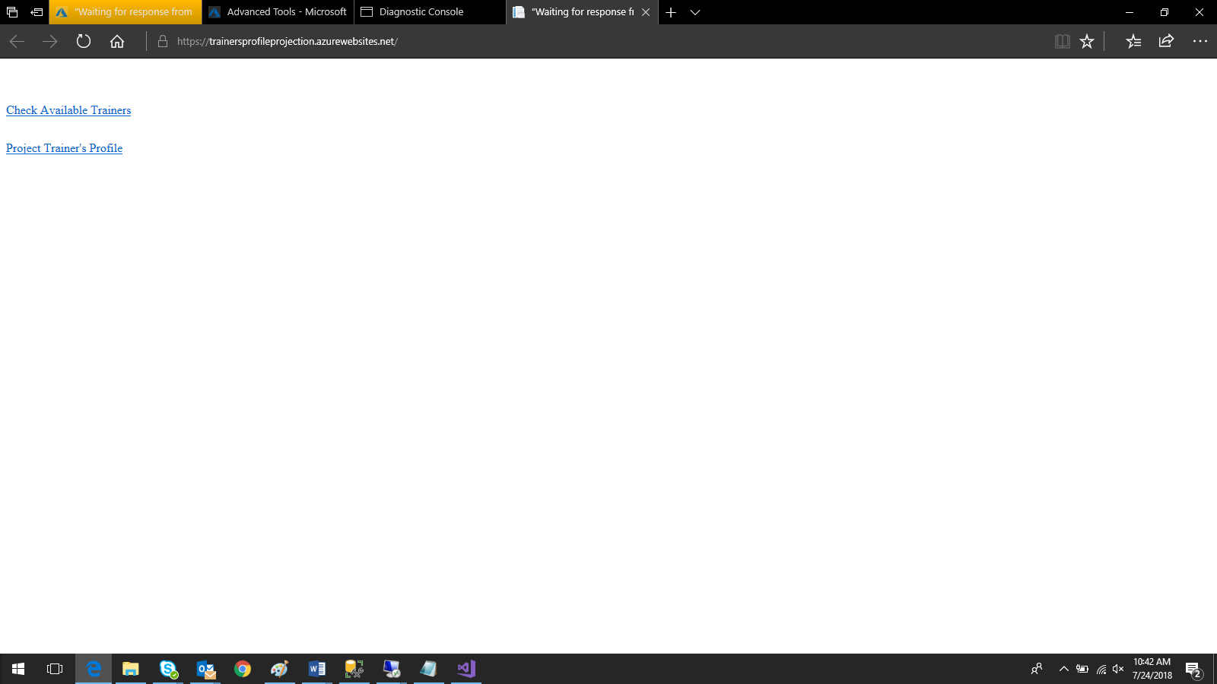

To check the published files:-

1. On the left panel, click on advanced Tools

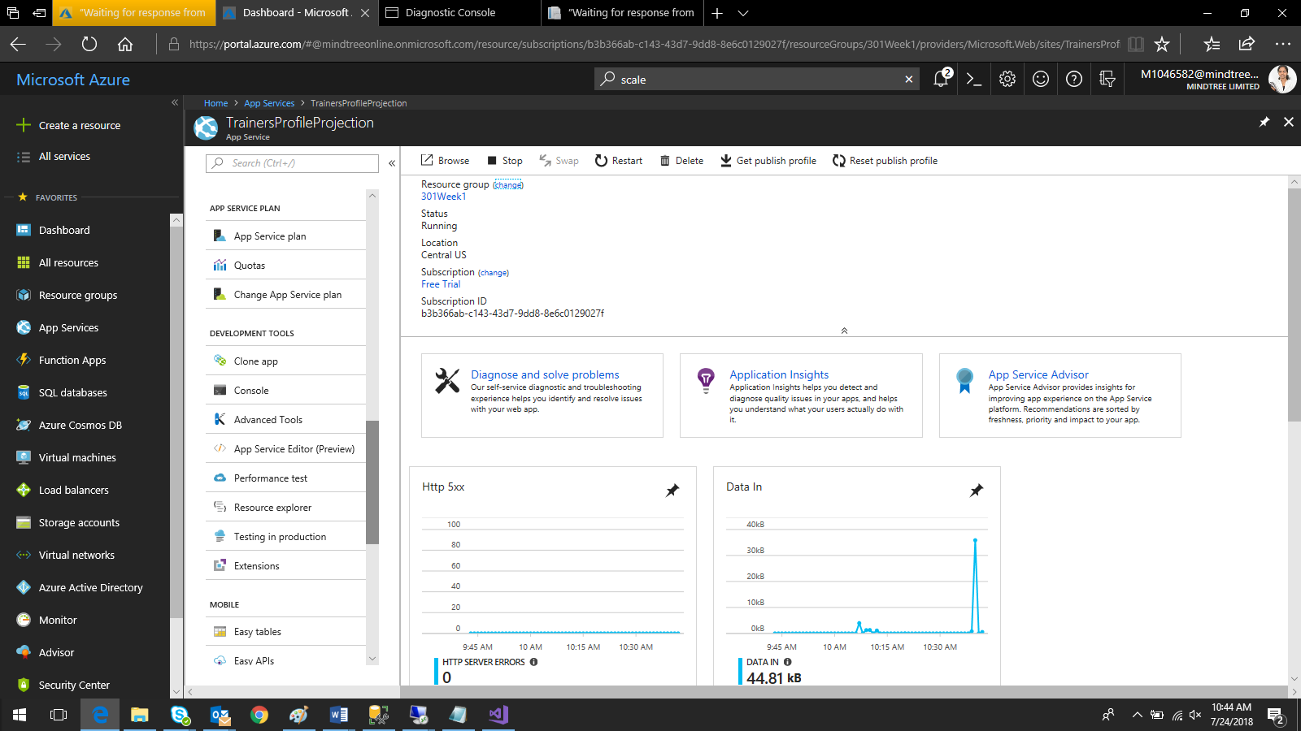

And click on Go🡪

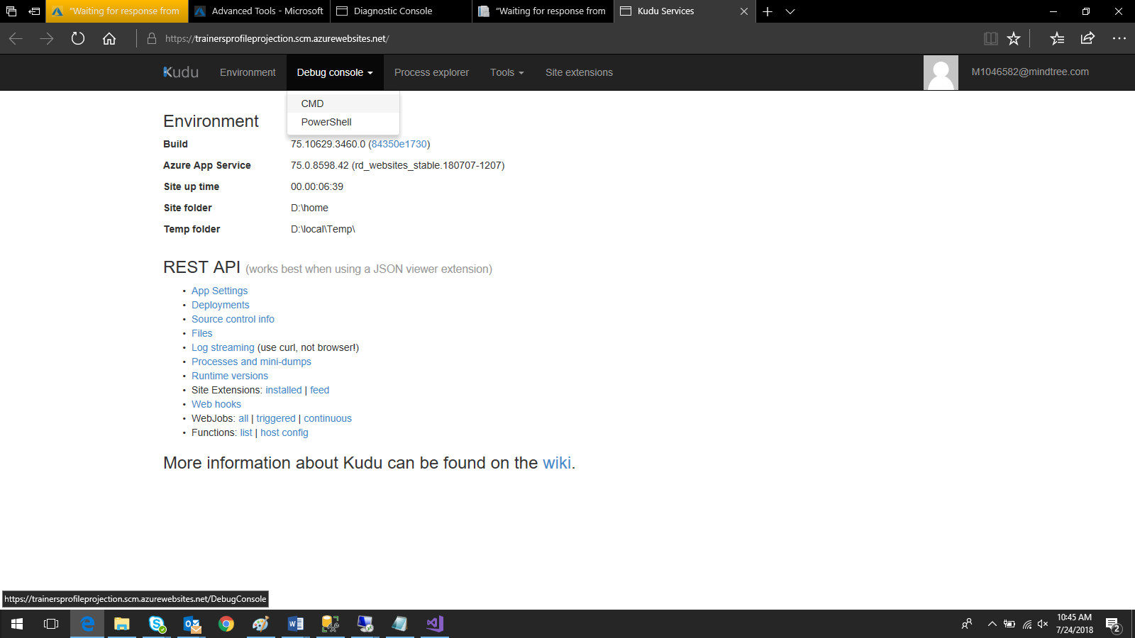

On the debug console, click on CMD



Click on Site

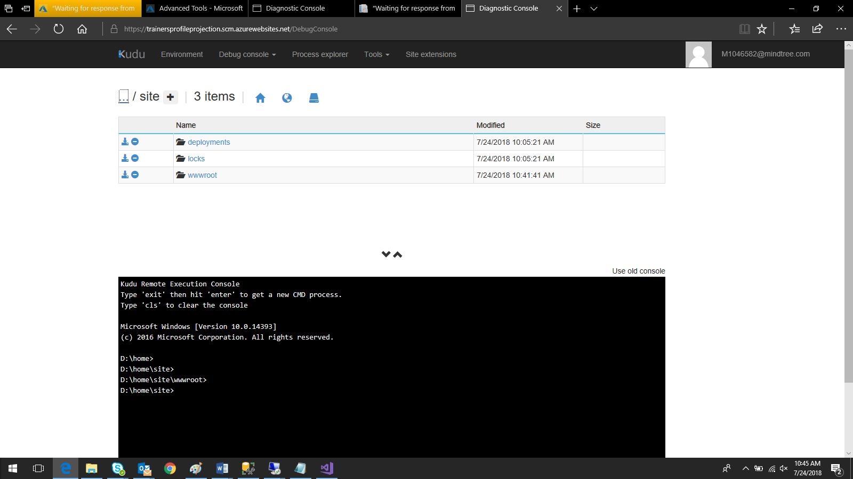

Click on wwwroot

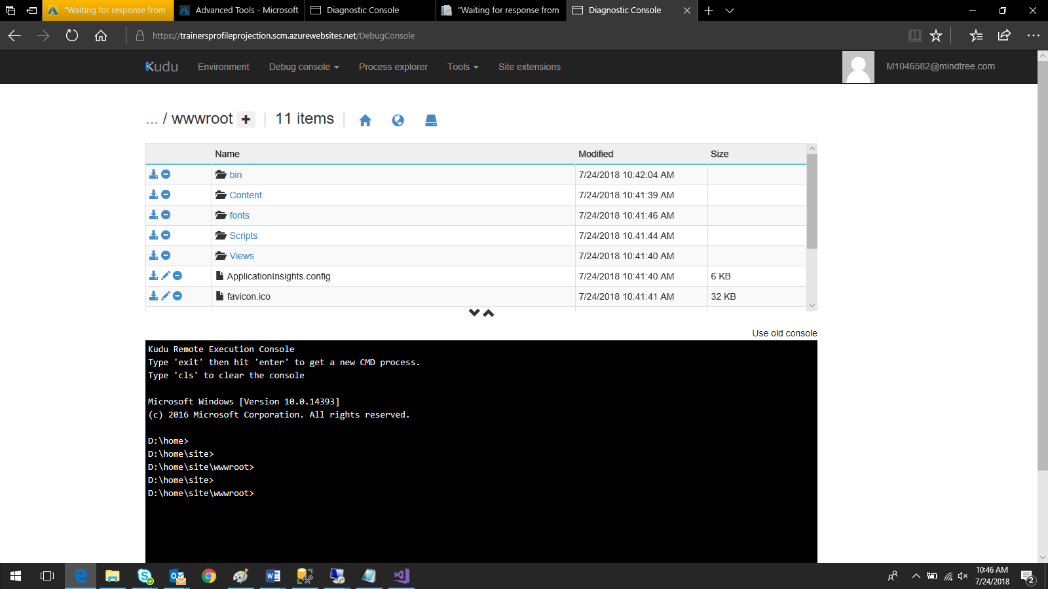

Published files are available here.

Note: if the published files are not available here after publishing, just publish the app in any folder and drag and drop the files here.

**Add Connected Service to use application insight**

Right click on Connected Service from the project and ‘Add Connected Service’

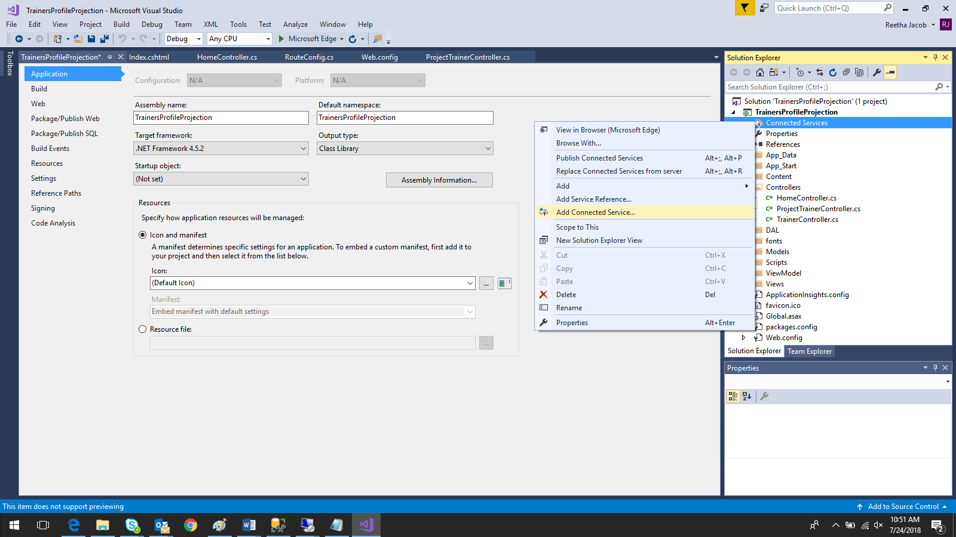

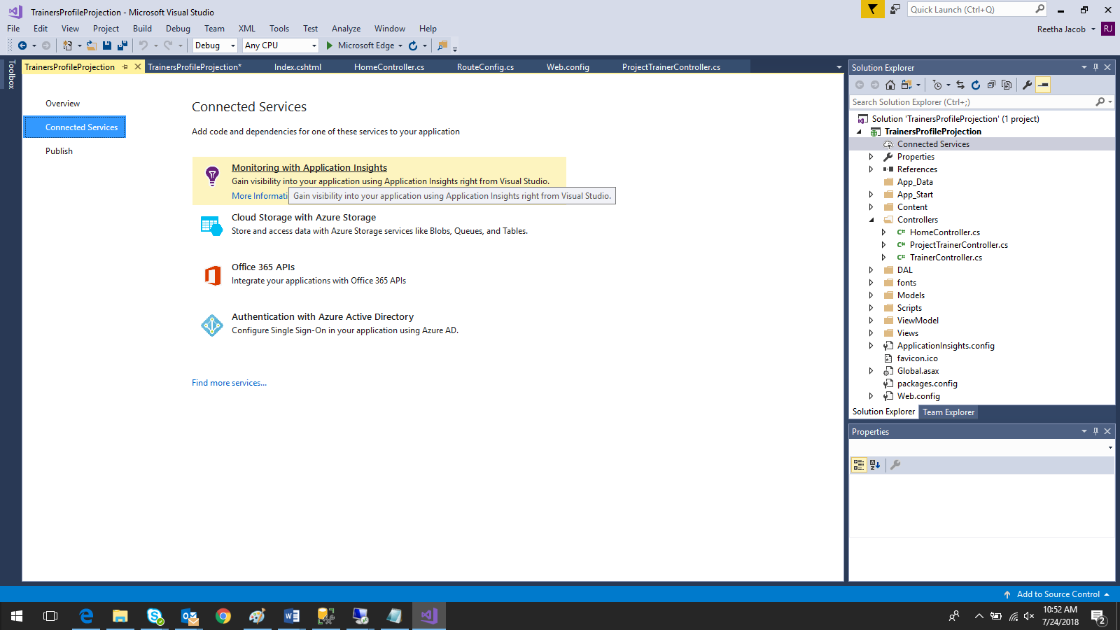

Click on ‘Monitoring with Application Insights’

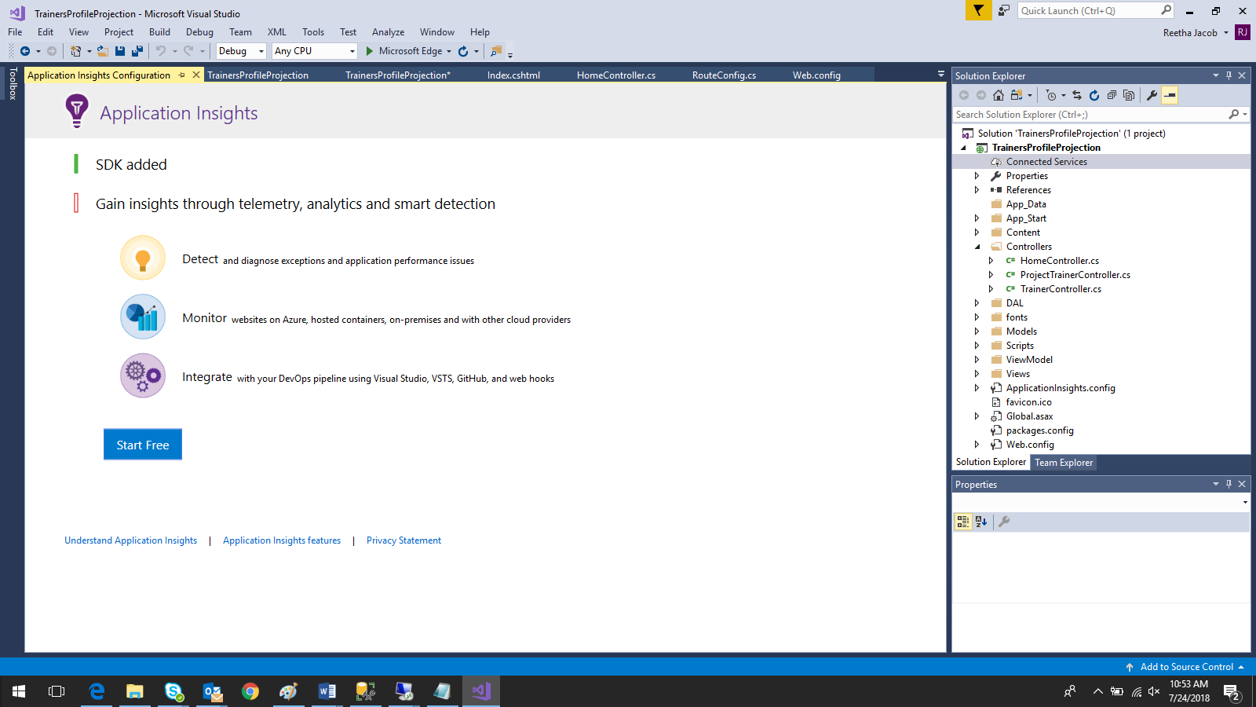

Click on Start Free

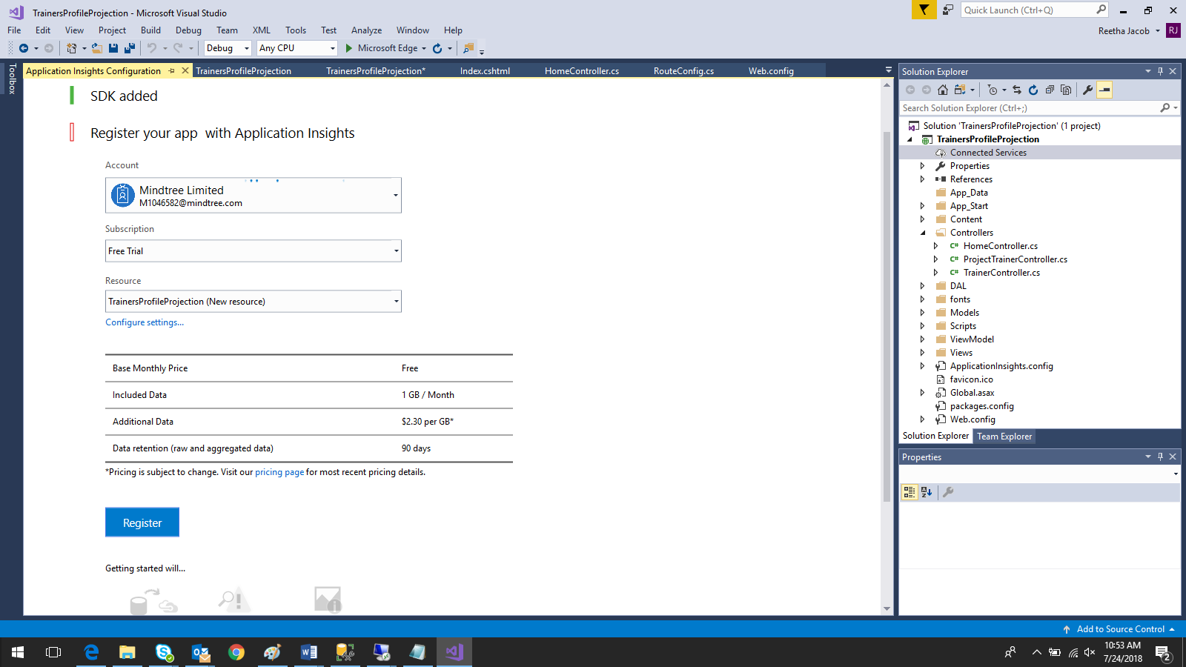

Click on Register

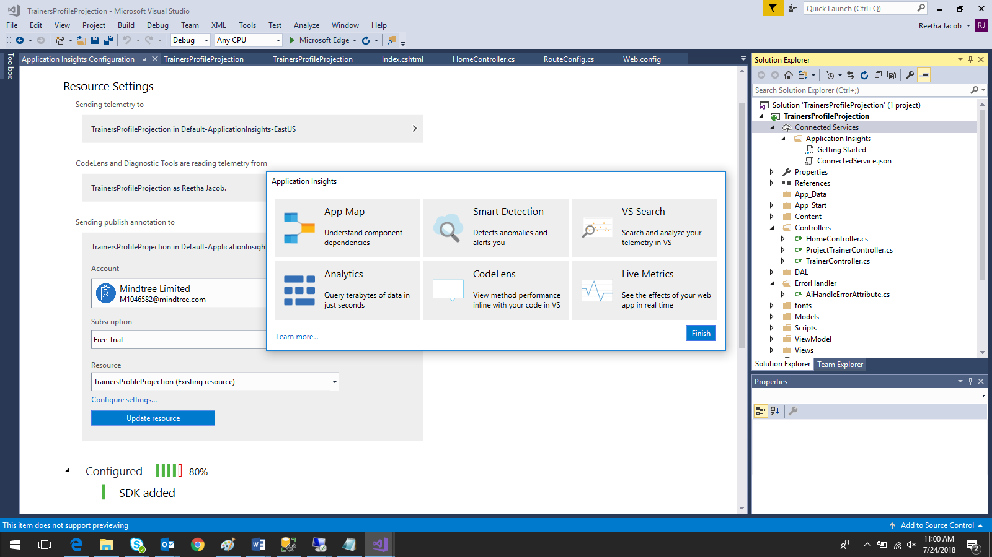

Click on Finish

**Application Insights**

Redeploy the application using App Services

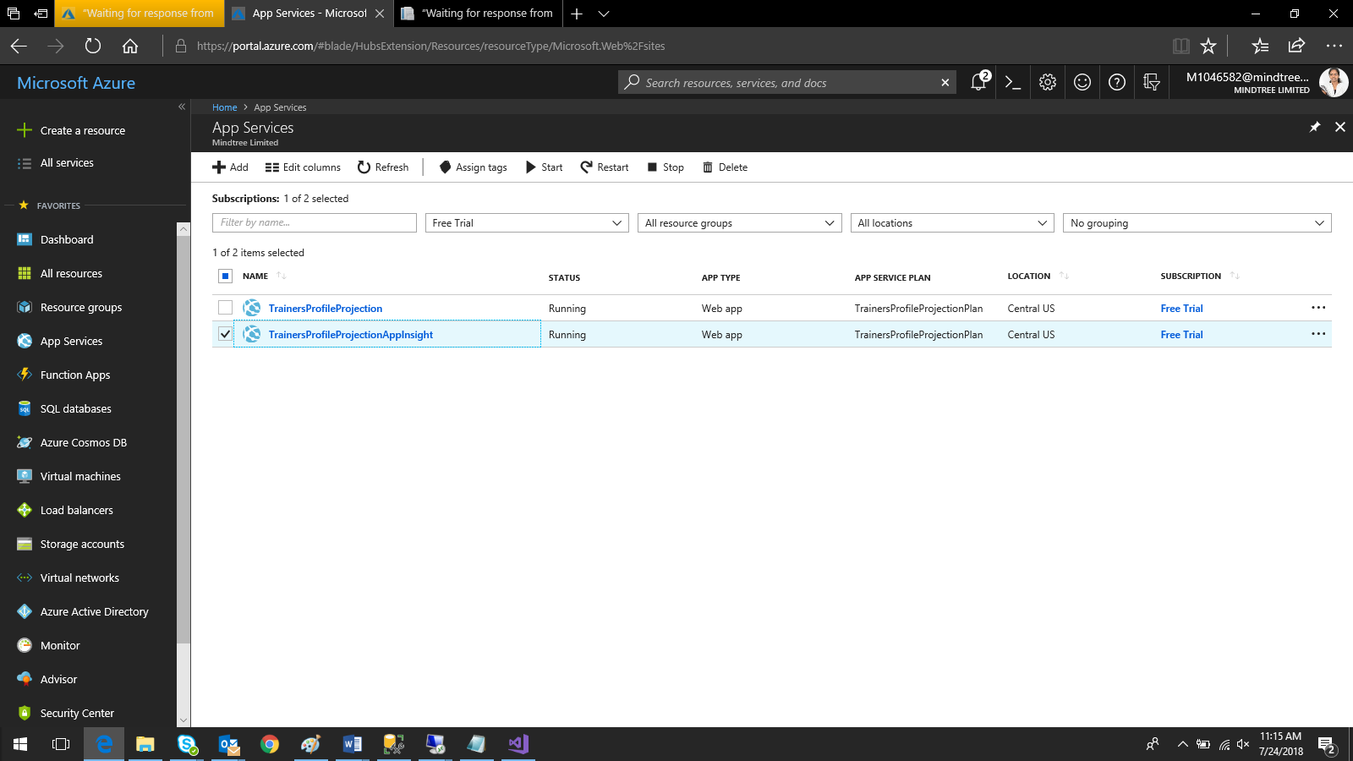

Click on ‘Overview’

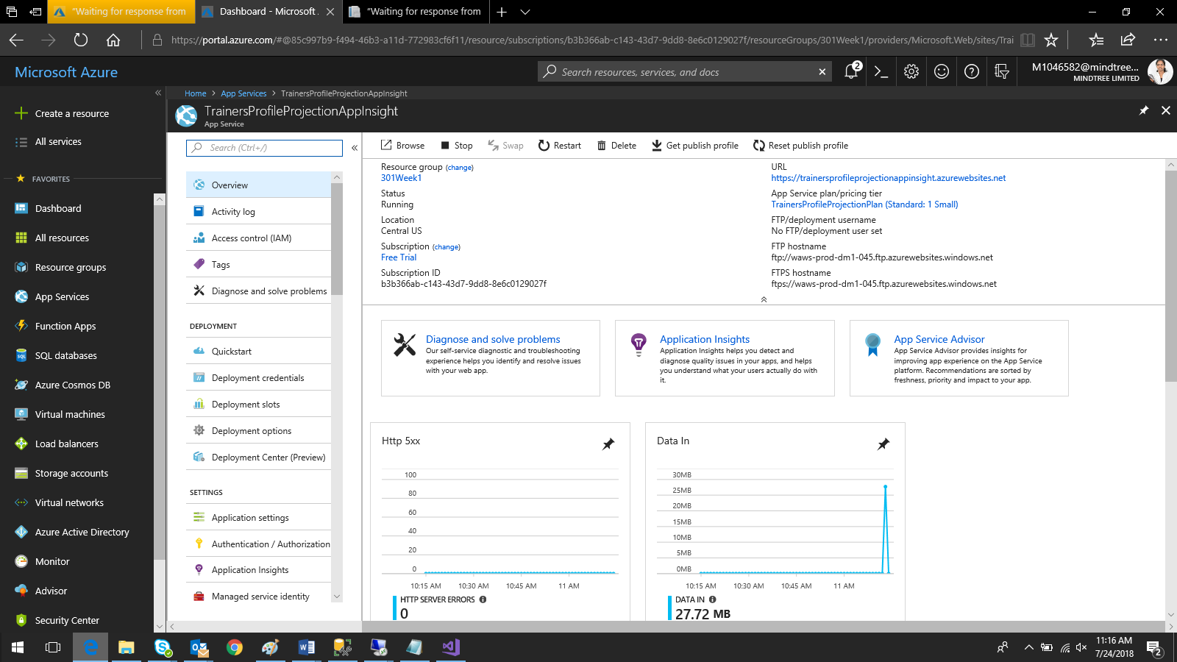

Click on Application Insight

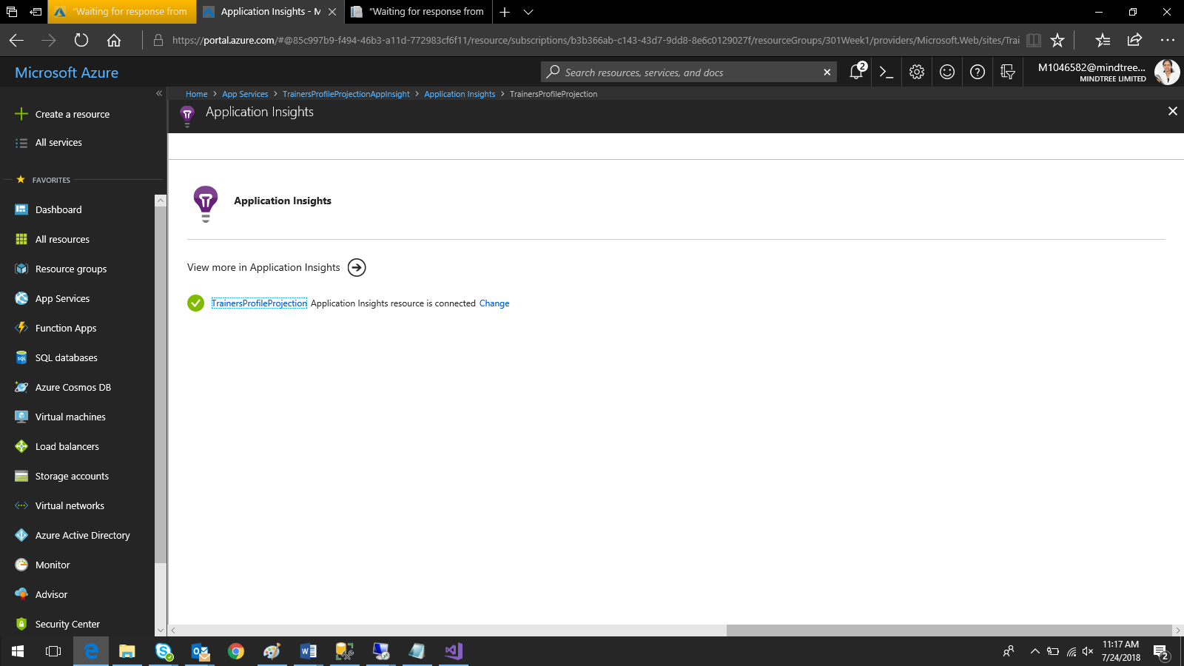

Click on the link

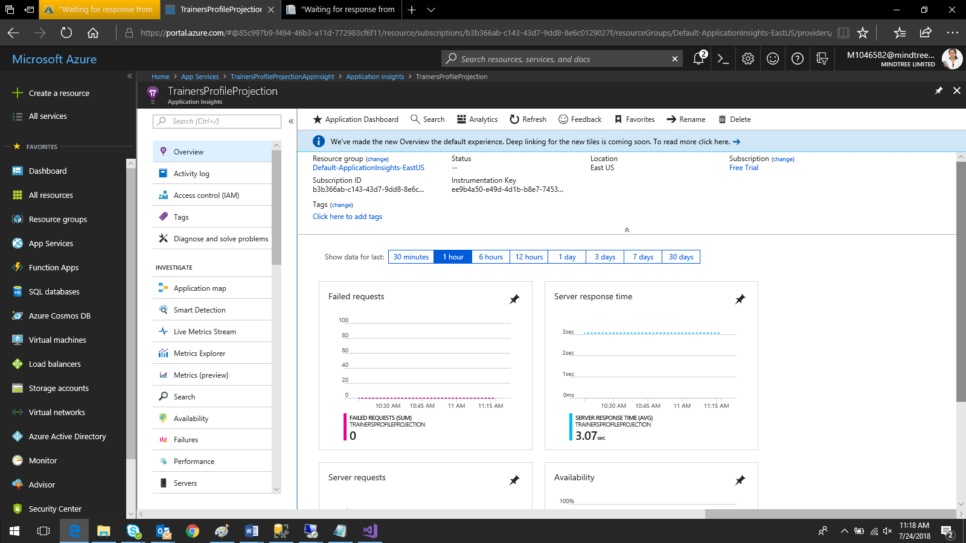

Create test from Availability

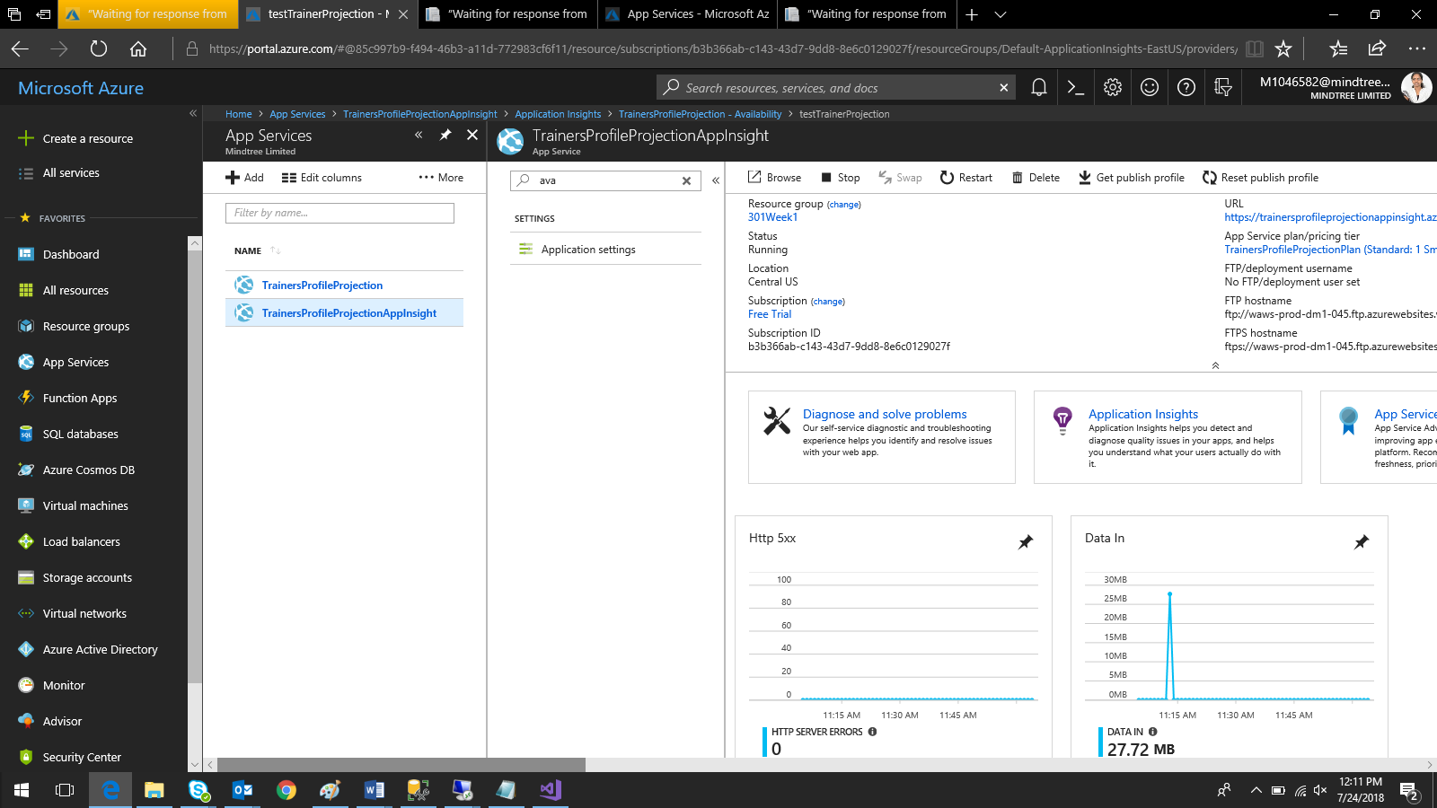

Click on Application insight

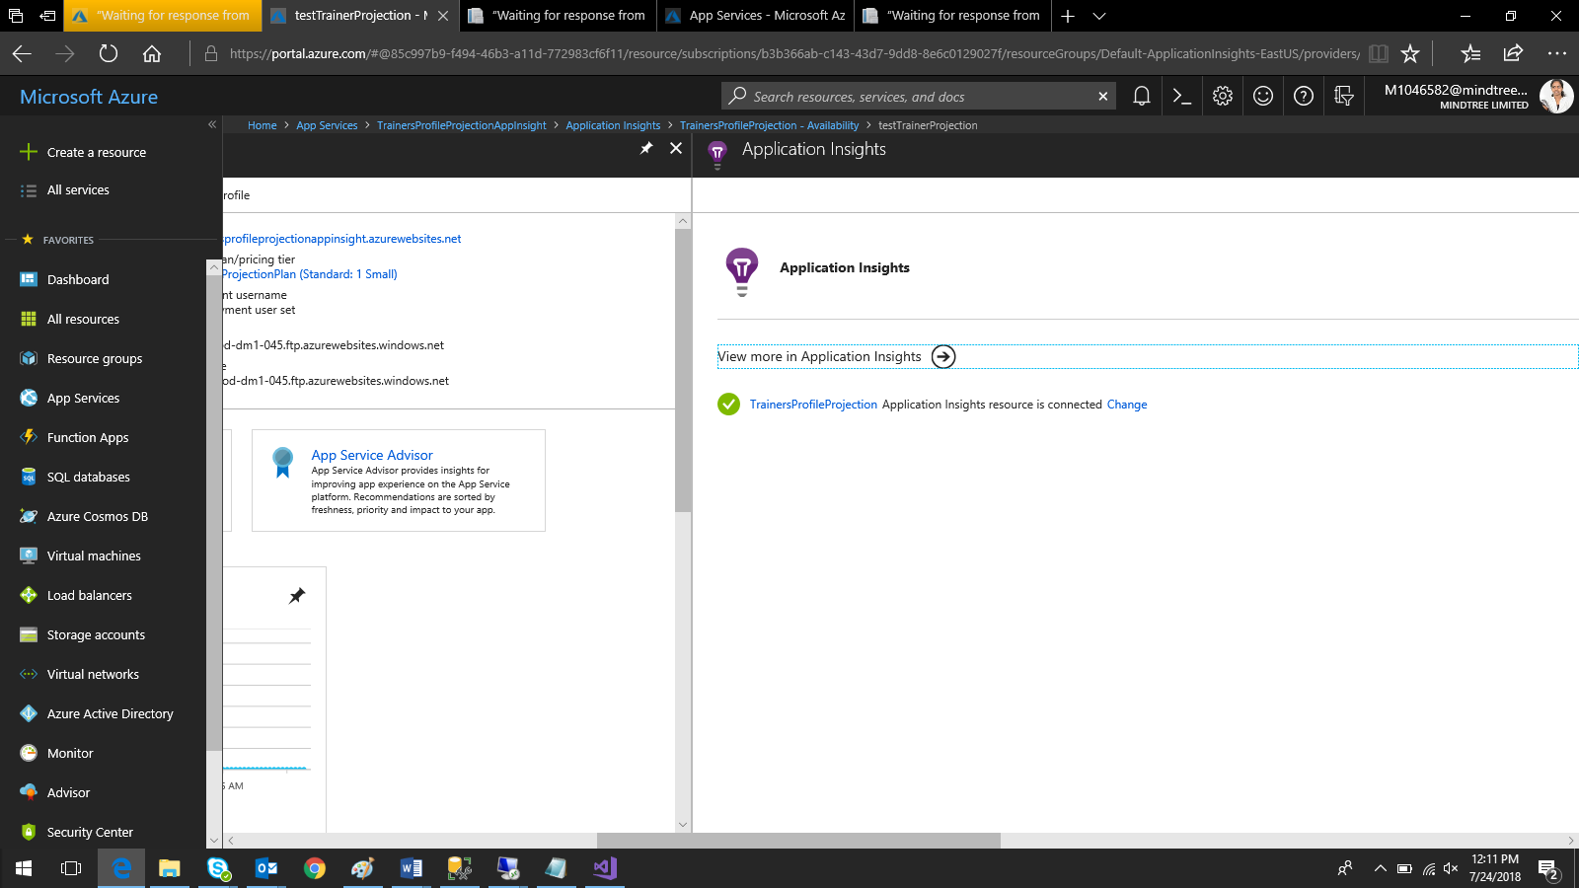

Click on the link given

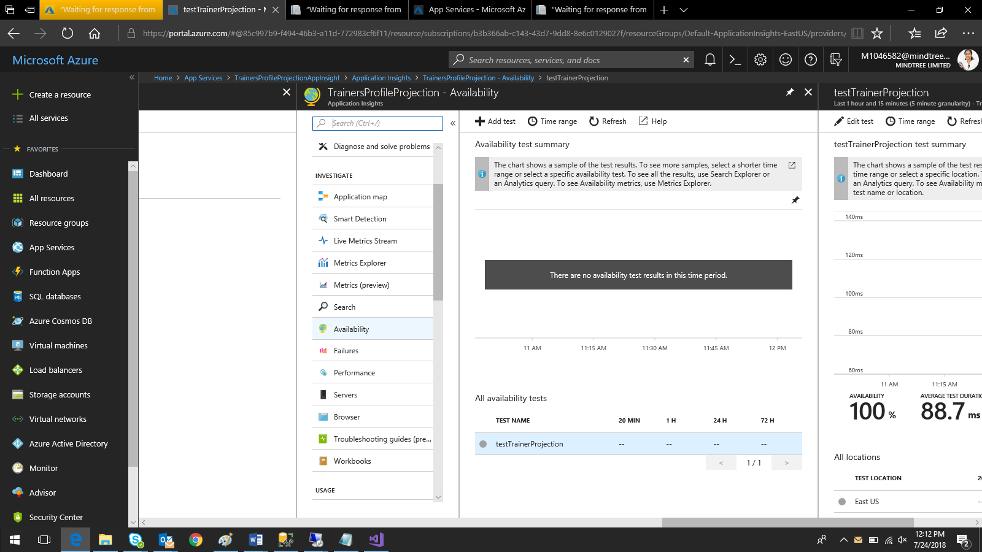

Click Availability on the left panel

And click on Add Test

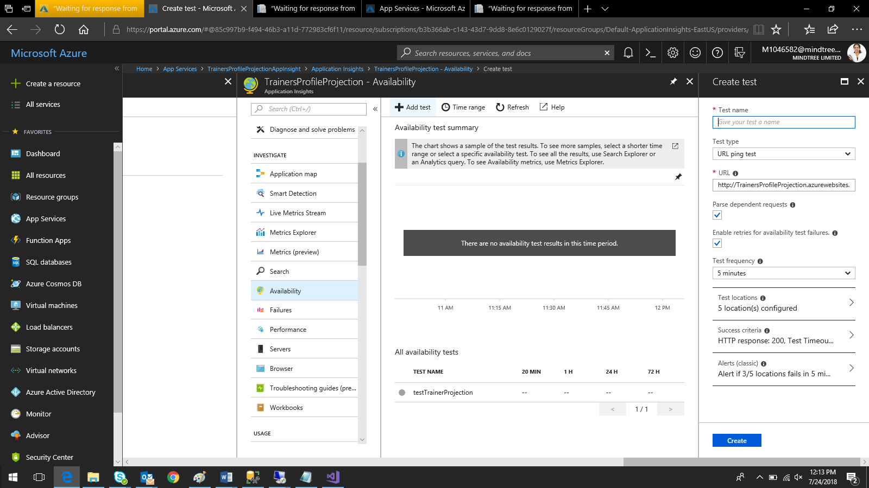

Enter the details and click on create.

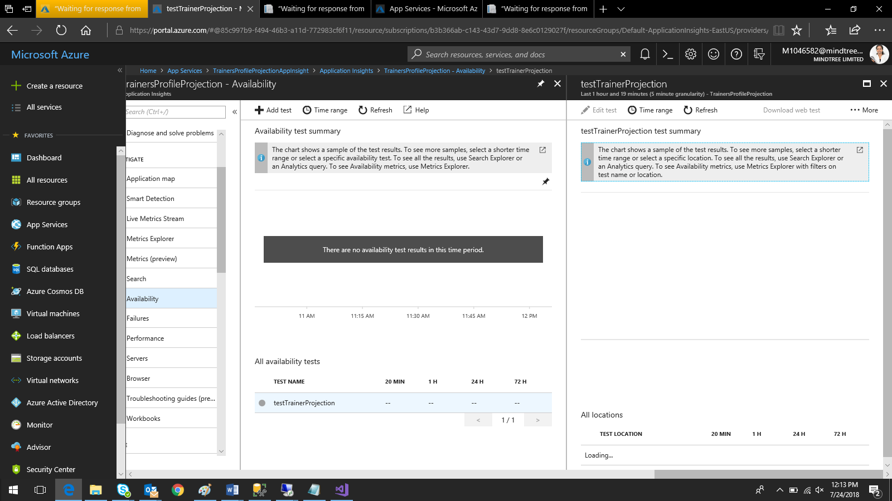

Do some operations on the website and check the graph.

